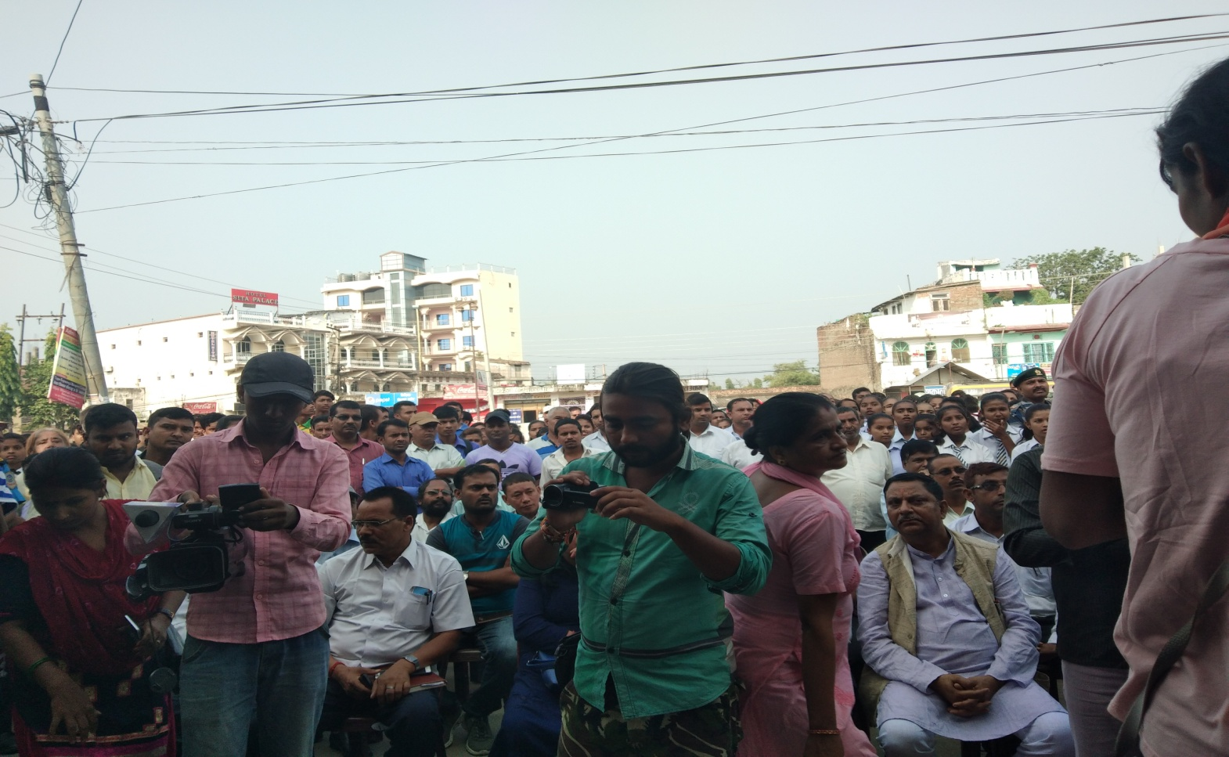
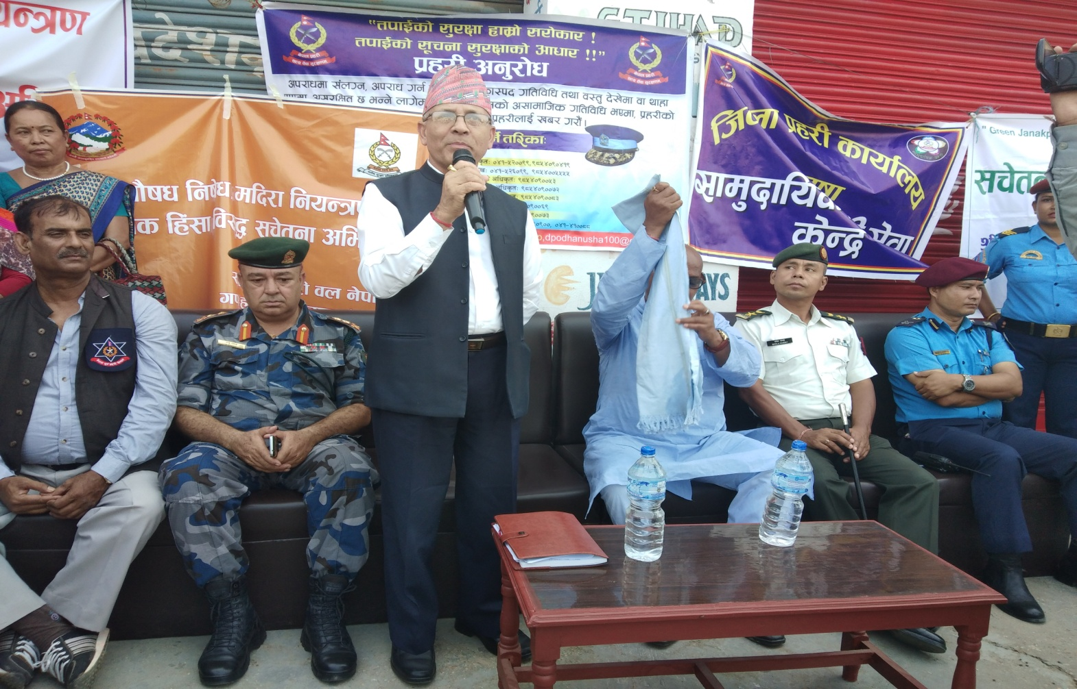
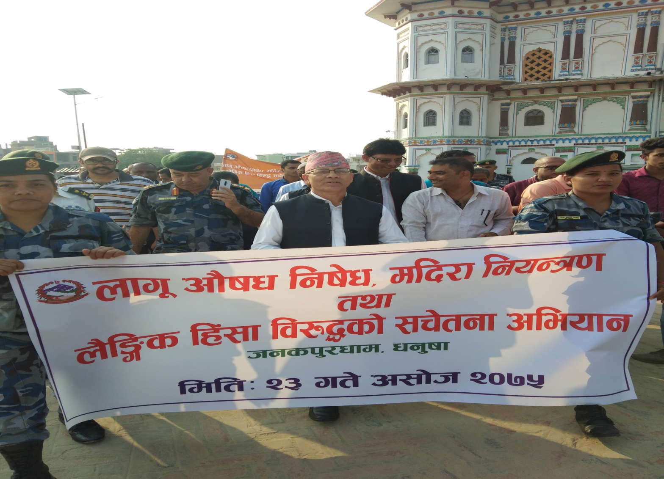
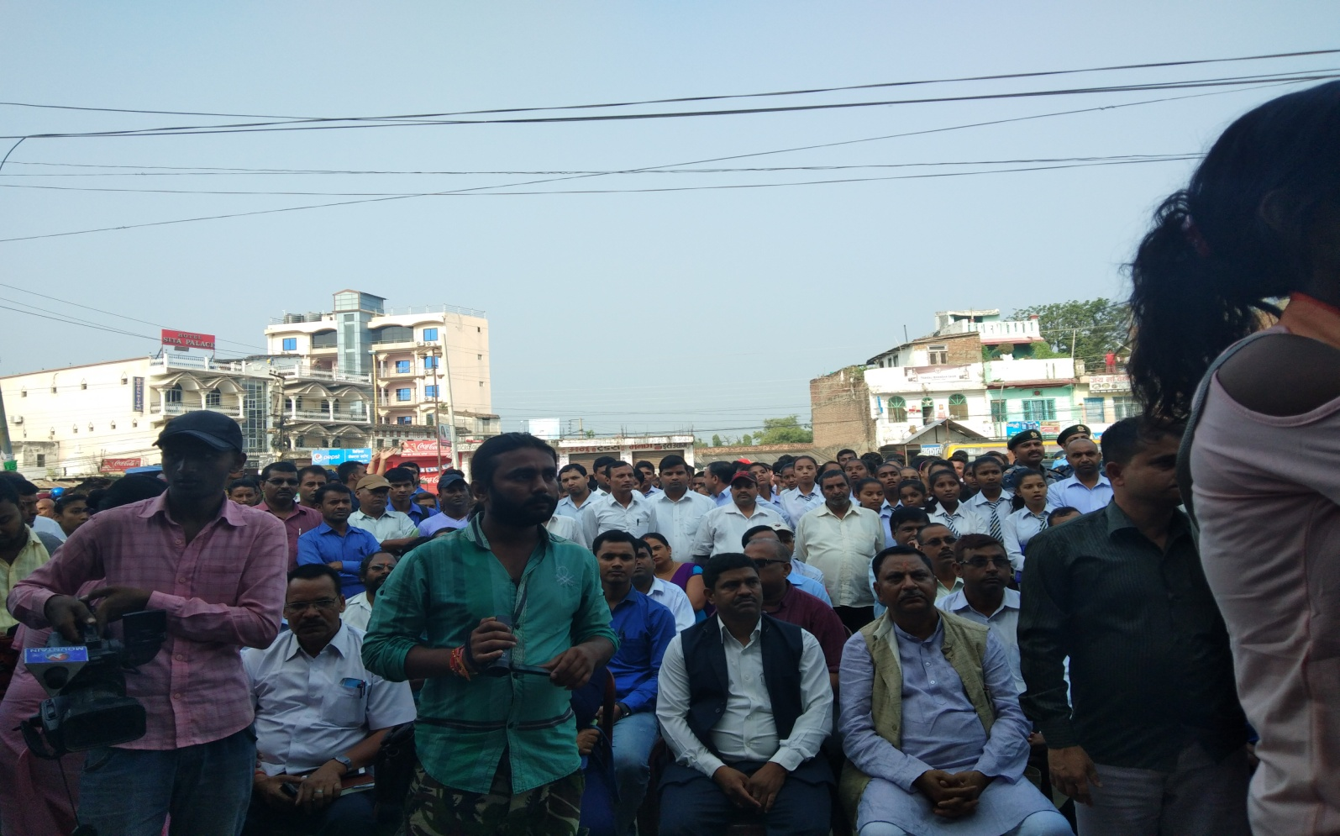
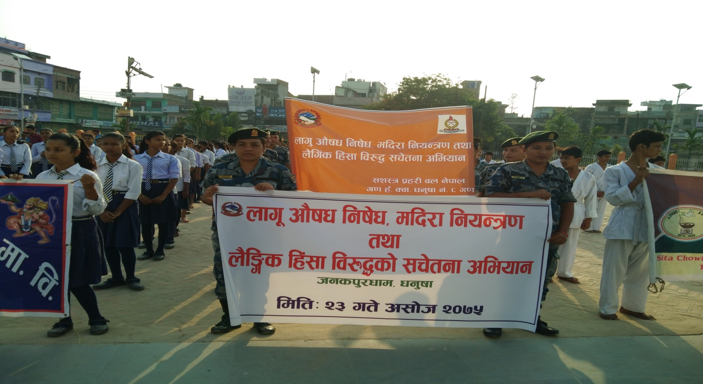

hgsk'/wfddf nfu" cf}ifw lgif]w, dlb/f lgoGq0f tyf n}lËs lx+;f lj?4 ljz]if ;r]tgf sfo{qmd (Campaign) ;DkGg .

cfh ldlt @)&%÷)^÷@# ut] ljxfg nfu" cf}ifw lgif]w, dlb/f lgoGq0f tyf n}lËs lx+;f lj?4sf] j[xt ;r]tgf cleofg ;DkGg ePsf] 5 . :yfgLo hfgsL dlGb/ k|fË0faf6 ¥ofnL ;'? eO{ /fdfgGb rf]sdf k'uL ;efdf kl/0ft ePsf] lyof] . k|=lh=c= k|]dnfn nfld5fg]sf] cWoIftf, hgsk'/ pkdxfgu/kflnsfsf k|d'v nfnlszf]/ ;fxsf] k|d'v cfltYotfdf ;DkGg ;f] sfo{qmdsf] p2]Zo dfyL k|x/L pk/LIfs uf]ljGb yklnofn] k|sfz kfg'{ ePsf] lyof] . lhNnf l:yt sfof{no k|d'vx?, sd{rf/Lx?, ;'/IffsdL{, :s"n÷sn]hsf lzIfs, ljBfyL{, /fhgLlts bn ;+j4, ;+3÷;+:yfsf o'jfx?, kqsf/, ljleGg ;+3÷;+:yfsf k|ltlgwLx? sl/j %)) hgfsf] ;xeflutf /x]sf] ;f] sfo{qmddf hgsk'/ pkdxfgu/kflnsfsf k|d'v nfnlszf]/ ;fx / k|=lh=c= k|]dnfn nfld5fg]n] dGtJo /fVg' ePsf] lyof] .

