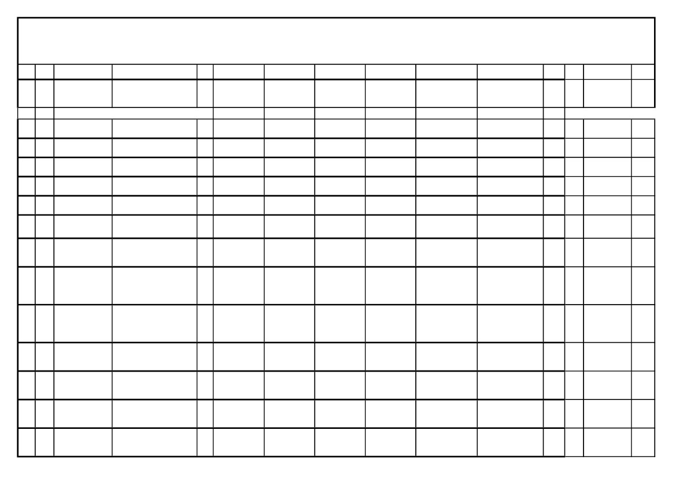
Government of Nepal
Ministry of Home Affairs
Nepal Hajj Committee
Name List of Haji-2019
S.N. DSN
Name
Address
Sex
Date of
Birth
Passport
No.
Passport
Issue Date
Passport
Expire Date
Meharam
Father/Mother
Entry AGE PHONE
Repat
Haji
Check
NO
NO
NO
NO
NO
NO
NO
DANUSHA
1
2
3
4
5
6
7
1
2
3
4
5
6
7
KALIM SAPHI
JAYLAM DEVI
MO HASIM SAH
DANAUJI-3
DANAUJI-3
DEVAPURARUPADAYA-4
M
F
M
F
M
F
M
23-Aug-1961
23-Jun-1958
14-Apr-1947
13-Apr-1976
13-Apr-1962
23-May-1964
17-Aug-1953
10307570 20-Mar-2017
10307587 20-Mar-2017
10662359 4-Dec-2017
11217559 20-Dec-2018
10589716 17-Oct-2017
10769907 8-Feb-2018
11123561 5-Oct-2018
11044326 13-Aug-2018
19-Mar-2027
19-Mar-2027
3-Dec-2027
19-Dec-2028
16-Oct-2027
7-Feb-2028
4-Oct-2028
GULM MURTAJA
KHAN(HUSBAND)
KALIM SAPHI
(HUSBAND)
BADRUN KHATUN SONIGAMA-9
GULM MURTAJA
KHAN
AMANA KHATUN
FAKIR MUTIM SA
MUTAHI PAREKHA-7
MUTAHI PAREKHA-7
THRAKASURI-6
KAHARA SAPHI
PANO KHATUN
PHAUDARA SAFI
PIYARIYA KHATUN
DIDARA ALI SHAH
OHIDANI KHATUN
DAUDA SARA
SAHIDA KHATUN
KHALIL KHAN
HASINA KHATUN
PUSUKA KHAN
YESA KHAUN
NEW 57
NEW 60
NEW 72
NEW 43
NEW 57
NEW 54
9854023254
9854023254
9807604706
9800865490
9819890763
9819890763
9826882226
EBRAHINA SAKAFIRA NEW 65
HABIYA KHATUN
JAMARUDHINA
SHAHA
PHAKIR
JAMISHA KHATUN
MOLABI MIYA
HANNA KHATUN
NEW 62
8
8
SAH PHAKIR
NAJAMUDDIN
DHERAKAKATI-6
M
16-Sep-1956
12-Aug-2028
9807617086
NO
9
9
SAIDA KHATUN
BINDIBELA-3
F
3-Jul-1958
11069207 30-Aug-2018
29-Aug-2028
MOLABI
MAHAMAD
HABIBULLA
(HUSBAND)
NEW 60
9803459287
NO
10
10
11
11
MOLABIBINDIBELA-3
MAHAMAD
HABIBULLA
PHAHIM AKHATAR YEDUKAHA-5
M
13-Apr-1954
11069190 30-Aug-2018
11189700 2-Dec-2018
11189619 2-Dec-2018
11189647 2-Dec-2018
29-Aug-2028
MO.YUSUFA KADARI NEW 65
SAKINA KHATUN
ALAUDINA MANSURI NEW 38
MAKINA KHATUN
ALI HUSEN MIYA
MARIYAM KHATUN
ATABUL MIYA
(HUSBAND)
SULEMAN MIYA
MAHAJITANI
KHATUN
NEW 56
9803459287
NO
M
28-Apr-1980
1-Dec-2028
9817603302
NO
12
12
ATABUL MIYA
BHARATPUR-1
M
22-Oct-1962
1-Dec-2028
9804869516
NO
13
13
AAISHA KHATUN
BHARATPUR-1
F
14-Apr-1963
1-Dec-2028
NEW 56
9804869516
NO


14
14
ALAUDIN
MANSURI
YEDUKAHA-5
M
7-Jul-1950
11192839 4-Dec-2018
11192816 4-Dec-2018
11210324 16-Dec-2018
11210349 16-Dec-2018
11122673 5-Oct-2018
11122671 5-Oct-2018
11229383 26-Dec-2018
3-Dec-2028
JUMMA MIYA
HADISANI KHATUN
ALAUDIN MANSURI SALIM MIYA
(HUSBAND)GUBDI KHATUN
SHESH RASID
MOMINA KHATUN
SHESH HANIF
SAKINA KHATUN
OKIL DARJI
SAMINA KHATUN
JAHURA DARJI
(HUSBAND)
KALIMA DARJI
MARIYAM KHATUN
ELIYASA HUSEN
RAHUNA
LATIPHANI KHATUN
JAMARDA RAENA
SAKINA KHATUN
SUWA KAWARI
SONIYA KHATUN
JASIBA MOMINA
RASULA KHATUN
SABAJANA MIYA
MANO KHATUN
GAFURA RAENA
SANECHARI KHATUN
NEW 68
9819841136
NO
15
15
MAKINA KHATUN YEDUKAHA-6
F
14-Mar-1953
3-Dec-2028
NEW 66
9819841136
NO
16
17
16
17
MOHAMMADLOHANA-9
MANSUR
SHAHIDA KHATUN LOHANA-9
M
F
19-Aug-1949
16-Feb-1953
15-Dec-2028
15-Dec-2028
MOHAMMAD
MANSUR
(HUSBAND)
NEW 69
NEW 66
9808117227
9808117227
NO
NO
18
19
18
19
JAHURA DARJI
SAMO KHATUN
KAPILESWOR-5
KAPILESWOR-5
M
F
10-Jul-1955
13-Apr-1957
4-Oct-2028
4-Oct-2028
NEW 63
NEW 62
9807838326
9807838326
NO
NO
20
20
MOBINA KHATUN BINDIBELA-3
F
12-Jul-1965
25-Dec-2028
NEW 53
9804815660
NO
21
22
23
24
25
21
22
23
24
25
MD KAMRUL HAQ BINDIBELA-3
RAIN
ABDUL KABARIBAHUAWA-9
ABASH MOMIN
LIYAKAT MIYA
KHATUN BEGAM
BAHUAWA-8
PARBAHA-07
DILLAYEDUWA-5
M
M
M
M
F
13-Apr-1961
18-May-1950
22-Sep-1959
22-Jun-1942
13-Apr-1956
11229372 26-Dec-2018
11234663 30-Dec-2018
11234547 30-Dec-2018
11234701 30-Dec-2018
08320197 1-Jan-2015
25-Dec-2028
29-Dec-2028
29-Dec-2028
29-Dec-2028
31-Dec-2024
MO USMAN RAIN
SIRAHA SN 28
(SON IN LAW)
NEW 58
NEW 68
NEW 59
NEW 76
NEW 63
9804815660
9812084770
9804806428
9804836697
9807649842
NO
NO
NO
NO
NO
26
26
JAMIRA KHATUN
MICHITEKSWOR-2
F
19-Dec-1952
10769833 8-Feb-2018
11148567 2-Nov-2018
11148642 2-Nov-2018
09447250 29-Dec-2015
10322785 29-Mar-2017
7-Feb-2028
ABDUL SAFIKA KHAN NEW 66
MINA KHATUN
MD KALI MUDIN
RAIN
(HUSBAND)
RAMAJO KAWARI
KUSAMA KHATUN
RAMAJO KAWARI
PHULIYA KHATUN
JUNANA AFI
SILYA KHATUN
WASIRA SAFI
JARINA PRABINA
NEW 62
9826822254
NO
27
27
JULEKHA KHATUN PRASAHI-3
F
29-May-1956
1-Nov-2028
9819659763
NO
28
29
30
28
29
30
MD KALI MUDIN
RAIN
FAGILA KHATUN
RIYAZ AHMED
PRASAHI-3
JANAKPUR-2
JANAKPUR-12
M
F
M
29-Jul-1951
16-Apr-1956
12-Mar-2001
1-Nov-2028
28-Dec-2025
28-Mar-2027
RIYAZ AHMED
(GRANDSON)
NEW 67
NEW 63
NEW 18
9819659763
9851077276
9851077276
NO
NO
NO

wg'iff lhNnfaf6 xhofqf ug{
hfgsf nflu 5gf}6 ePsf JolQmx?sf] gfdfjnL

